**10. Reactjs-HOL**

**Step 1:** Create a react app by name **‘officespacerentalapp’**



**Step 2:** Create a Header section with name **Header.js** and the following code inside it, added a bit of inline css to make it look better.

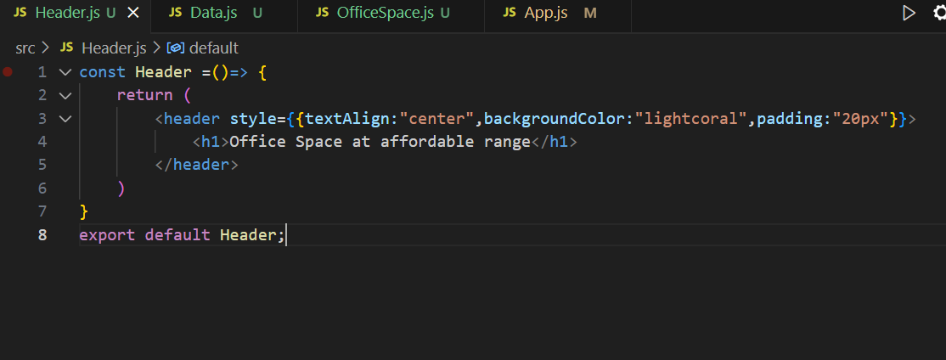

**Step 3:** Create a component which will hold all of the data with name **Data.js,** Also added **image** property to the Array of Objects to make rendering of image easy and Optimize the code as there are multiple Objects.

**Note :-** Place all the Downloaded images in the public folder for this to work.

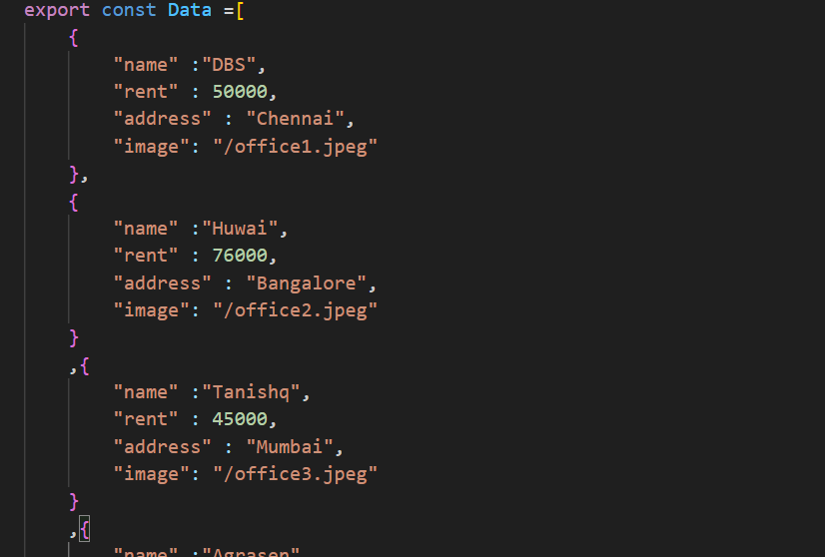

**Step 4:** Create an **OfficeSpace.js** Component to deal with the rendering of data and added a bit of inline css to make it look more presentable.

For the color of text in rent property of object to change dynamically, I added inline css with **conditional rendering** property of javascript.

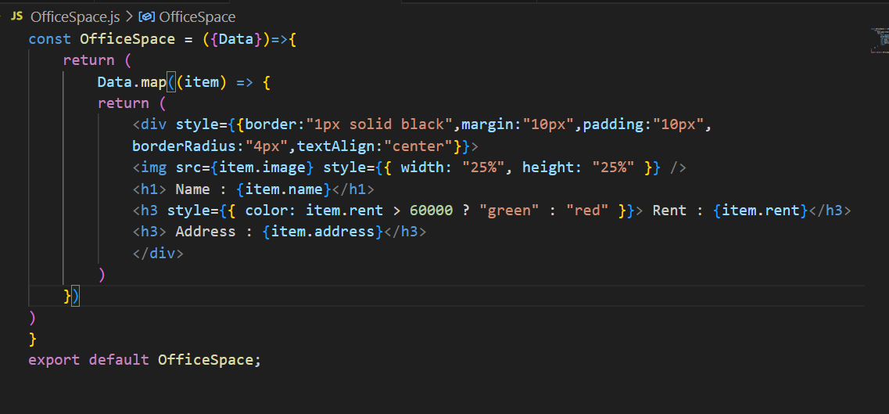

**Step 5:** Download any random image from internet and place them to your public folder, since we have only 4 objects in our **Data.js** file, we downloaded 4 images. We can also add http link to any opensource image directly into our object’s image property.

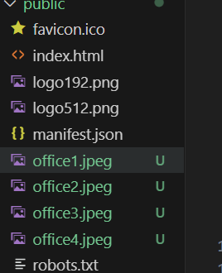

**Step 6:** Add the following code in App.js file

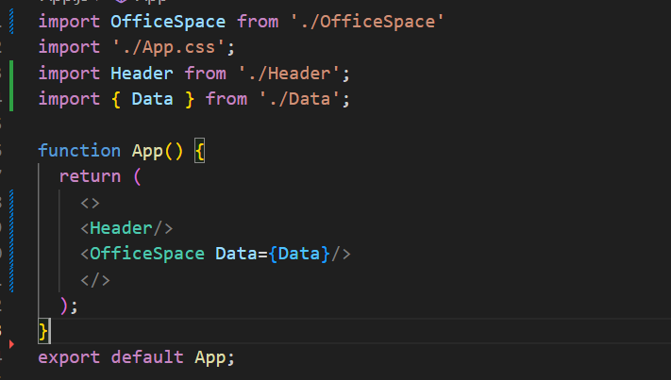

**Output:** Your Output should look something like this.

